**Metal Roofing Substrates and Coatings Explained**

Posted by [**McElroy Metal**](https://blog.mcelroymetal.com/homeowners-blog/author/mcelroy-metal) ●

July 31, 2019

Gone are the days of limited options for metal roofing.  In fact, today's metal roof buyers can choose from a dizzying array of both colors and styles.  And there's certainly no doubt that like many other purchases, aesthetics are an essential part of the selection process with metal roofing. However, it's also important for buyers to consider the quality of the metal substrates and coatings for those situations when life expectancy and long-term performance are important.

**Metal Roofing Substrates**

Underneath the paint/coating, the substrate of the actual metal is the heart of a metal roof.

There are two common steel substrates available today, Galvanized and Galvalume®. [**Galvanized substrates**](https://www.mcelroymetal.com/substrate-and-coating-facts) feature a zinc coating applied to the raw steel while Galvalume® substrates feature an alloy of zinc plus aluminum. Both of these substrates are of good quality. However, Galvalume® substrates offer homeowners the highest quality long-term solution.

If a homeowner is considering Galvanized substrates, it is important to understand the difference between G100 and G60 Galvanized substrates. The numerical designation refers to the amount of zinc contained on both sides of the panel surface. When it comes to performance, the higher the amount of zinc, the more resistant to panel will be against corrosion.

With 66% more zinc than G60 substrates, G100 substrates will last far longer than their G60 counterparts. In fact, this direct correlation between zinc amounts and performance means that G60 substrates are not generally considered appropriate for residential roofing. That being said, G60 substrates are widely available in the market place, so it's crucial for homeowners to understand the difference in performance and ask questions.

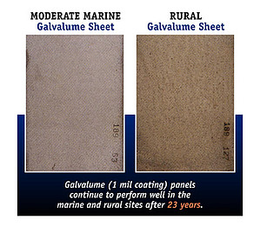

At McElroy Metal, we generally recommend homeowners opt for a Galvalume® substrate over even a G100 substrate. (Based on performance limitations, we don't even offer a G60 for residential applications). Our recommendation is based on our experience that Galvalume® delivers better results, excellent corrosion resistance, and long-term aesthetics. Galvalume® substrates also carry a [**warranty**](https://blog.mcelroymetal.com/homeowners-blog/shingles-vs-metal-warranty-comparison) against rupture or perforation from corrosion. Similar warranties for Galvanized substrates simply don’t exist.

**Metal Roofing Coatings**

Beyond simple color selection, the paint system you select for your new roof can have long-lasting implications for performance. Remember, the paint system on your metal roof comes into direct contact with all the UV rays and weather that nature has to offer. The environmental conditions will work over time to breakdown the coating, resulting in panel fade and chalk.

There are three types of paint systems commonly available to homeowners, Polyester, Silicone-Modified Polyester (SMP), and [**Kynar 500® (PVDF)**](https://blog.mcelroymetal.com/homeowners-blog/how-kynar-500-protects-your-roof).

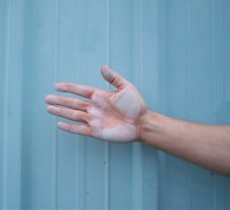

Polyester systems are the least expensive option but are also the lowest performing. With the highest amount of chalk and fade, Polyester systems have the shortest lifespan and are not typically recommended for residential roofing.

Silicone-Modified Polyester (SMP) is a better preforming option than the Polyester systems. The SMP paint systems will still experience fade and chalk, but not to the same degree as Polyester coatings.

PVDF (Kynar 500®) paint systems are the best performing option available to homeowners. In terms of service life, color retention, and chalk-resistance. PVDF’s (Kynar 500®) paint systems are superior and will offer a like-new appearance for years to come.

It is perhaps easiest to "see" the difference in quality with Kynar 500® paint systems. The image below shows a home that had the exact same color SMP and Kynar 500® coated panels installed. Eight years after later, the image below was taken.  Notice the stark contrast in performance between the two systems.  The Kynar 500® roof still looks like new and the SMP roof is experiencing significant fade and chalk.  Learn more about [**metal roofing coatings and substrates**](https://www.mcelroymetal.com/mcelroy-university/metal-roofing-substrate-and-coating-facts).

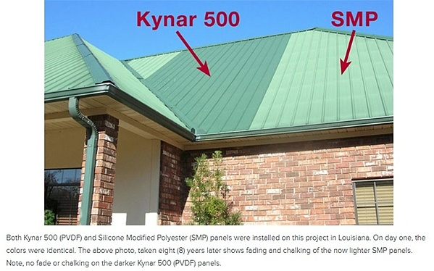

**Learn More**

Want to learn more about selecting a metal roofing system for your home? The Residential Metal Roofing Guide explains the most common types of residential roofing substrates, coatings, warranties, and panel options. Click the link below to download your copy!

Learn everything you to know about [**Residential Metal Roofing**](https://www.mcelroymetal.com/residential-metal-roofing). Check our out [**metal roofing resources**](https://www.mcelroymetal.com/residential-metal-roofing/resources) for inspiration and answers to your questions.

**About McElroy Metal**

Since 1963, McElroy Metal has served the construction industry with quality products and excellent customer service. The family-owned components manufacturer is headquartered in Bossier City, La., and has 13 manufacturing facilities across the United States. Quality, service and performance have been the cornerstone of McElroy Metal’s business philosophy and have contributed to the success of the company through the years. As a preferred service provider, these values will continue to be at the forefront of McElroy Metal’s model along with a strong focus on the customer. More information can be found at http://www.mcelroymetal.com.